CASAS (Center for Advanced Studies in Adaptive Systems):

CASAS is arguably the "Gold Standard" for ambient sensor-based smart home research. It is widely cited, well-documented, and perfect for testing machine learning models without the privacy concerns of video cameras.
Unlike systems that use cameras (which are invasive) or wearables (which people forget to wear), CASAS uses Ambient Intelligence. This means the house itself "feels" the resident's presence.

Sensor Code | Type | Description & Purpose
M or P | Motion (PIR) | Passive Infrared sensors placed on ceilings. They detect movement in specific zones (e.g., "Kitchen Area"). Purpose: Localization and trajectory tracking.
D | Door/Window | Magnetic contact switches (Reed switches). Purpose: Detects entry/exit or interaction with cabinets/fridges (crucial for "Cooking" vs. "Eating").
T | Temperature | Thermistors. Purpose: Detects ambient heat changes or cooking heat signatures.
L | Light | Ambient light sensors. Purpose: Detects sleep/wake cycles or usage of artificial lighting.
I | Item | Wide-area sensors on specific objects (less common in newer datasets).

Paper 1:
Title: CASAS: A Smart Home in a Box
Author/Year: Cook et al., 2013
Link: https://pmc.ncbi.nlm.nih.gov/articles/PMC3886862/#S1
The core problem identified in this paper is that "smart homes" are often too complex, expensive, and difficult to set up. They usually exist only in high-tech laboratories.
The solution proposed by the CASAS project at Washington State University is a "Smart Home in a Box" (SHiB). This is a compact, easy-to-install kit that anyone can set up in their home without technical training. It uses Artificial Intelligence (AI) to learn the residents' habits to help with health monitoring and energy efficiency.
The Challenge: Historically, creating a smart home required tearing up walls to wire sensors and hiring experts to configure complex software. This made it impossible to test smart homes on a large scale (e.g., across hundreds of regular houses).
The CASAS Solution: The researchers designed a kit that fits in a single box. It is:
- Lightweight: Easy to carry and ship.
- Simple: Can be installed in about one hour by a regular person.
- Non-invasive: Sensors are stuck to walls/doors; no construction is required.
Architecture:
1. Physical Layer (The Senses): This consists of hardware like motion detectors, door sensors, and temperature sensors. They talk to each other using a wireless network (Zigbee).
2. Middleware Layer (The Nervous System): This is the software that connects everything. It takes the raw data from the sensors and organizes it. It was designed to be "maintenance-free," meaning it fixes itself if a connection drops.
3. Application Layer (The Brain): This is where the intelligent decision-making happens. The software looks at the data and decides what to do (e.g., "The resident is cooking, so monitor the stove").
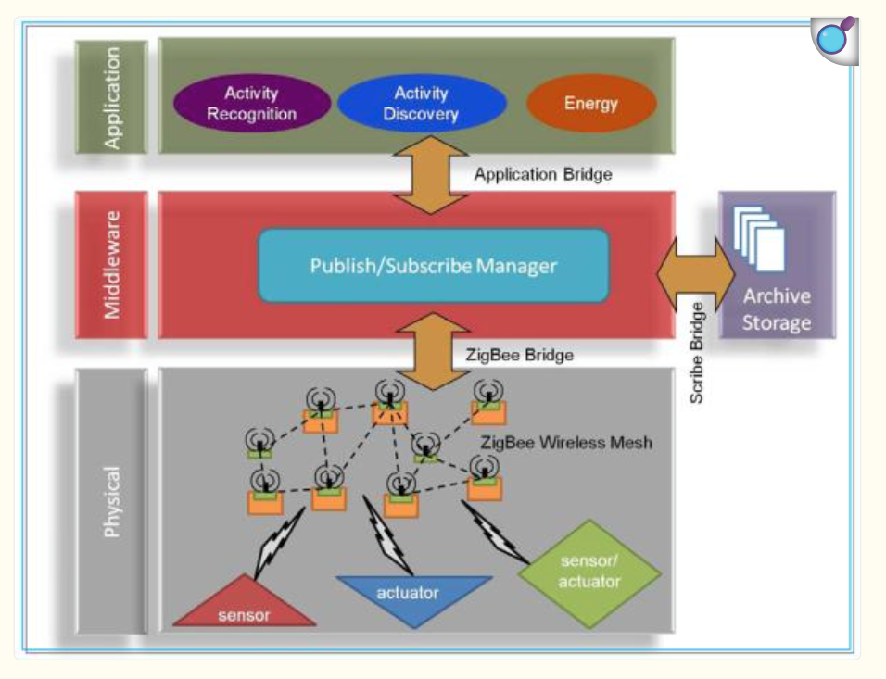
A. Activity Recognition (AR)
This is the system's ability to label known actions. The computer looks at a stream of data (e.g., "Motion in Kitchen" -> "Stove On" ->"Fridge Open") and uses a machine learning model called a Support Vector Machine (SVM) to label that sequence as "Cooking."
The system was tested in 18 different apartments and could correctly identify activities with 84% accuracy without needing special training for each specific house.
B. Activity Discovery (AD)
Sometimes, humans do things that the computer wasn't programmed to recognize. "Activity Discovery" is an unsupervised learning method. It scans the data for repeating patterns that don't have a label yet.
- Example: If the sensors notice that every day at 10:00 AM, the user goes to the bedroom, then the living room, then back to the bedroom, the system identifies this as a distinct "Pattern."
- This helps the system learn the unique quirks and routines of a specific resident.

Real-World Applications
The researchers focus on two major benefits of this technology:
- Health Assistance (Aging in Place): With an aging population, it is important to help elderly people live safely at home. The system tracks "wellness parameters" such as sleep quality, mobility, and how often they eat. If a resident's behavior suddenly changes (e.g., they stop getting out of bed), the system can alert caregivers.
- Energy Efficiency: By knowing what the resident is doing, the house can automate electricity usage. For example, if the system knows the resident is "Sleeping," it can ensure lights and unnecessary appliances in other rooms are turned off.
Advantages:
• Ease of Install: Every participant successfully installed the smart home.
• Speed: The average installation took just over one hour.
• Difficulty: On a scale of 1 to 10 (10 being impossible), participants rated the difficulty a 2.53.

Population Analysis: Because these kits are so easy to deploy, the researchers were able to analyze data across many homes. They found consistent patterns in human behavior, such as activity levels peaking in the mid-morning and early evening, and dipping in the early afternoon.

Conclusion
The CASAS "Smart Home in a Box" successfully bridges the gap between high-tech research and real-world use. By making the hardware simple and the software intelligent, it paves the way for homes that actively look after our health and reduce our energy consumption.
Paper 2:
Title: Recognizing Independent and Joint Activities with Motion Sensors
Author/Year: Singla et al., 2010
Link: https://pmc.ncbi.nlm.nih.gov/articles/PMC2958106/

The primary goal of this research is to solve a specific problem in healthcare technology: How can a smart home look after an elderly person when they don’t live alone?
While single-person smart homes have been studied extensively, most real-world homes have multiple people (spouses, family members). This paper introduces a method to track "Activities of Daily Living" (like cooking, cleaning, or taking medicine) even when two people are doing different things at the same time, or working together.
Challenges:
The "Cluttered" Data Problem
- The Context: As the population ages, many elderly individuals wish to live independently. However, caregivers need to know if their loved ones are eating, taking medication, and staying active.
- The Problem: Previous smart home systems assumed only one person was in the house. If Person A is cooking while Person B is cleaning, the sensors get "confused" by the simultaneous data.
- The Objective: To build a mathematical model that can disentangle these activities and correctly identify who is doing what.

The Setup: The Smart Apartment Testbed:
They equipped it with a network of "passive" sensors. These are sensors that do not require the human to wear anything or do anything special.
- Motion Sensors: Placed on the ceiling to track movement.
- Contact Sensors: On doors, cabinets, and medicine containers to detect opening/closing.
- Utility Sensors: To detect if the stove burner or water faucet is on.

The Experiment: They recruited 40 participants to act as residents. Two people occupied the apartment at the same time and performed a script of 15 specific activities.
- Individual Activities: E.g., Person A reads a magazine while Person B sweeps the floor.
- Cooperative Activities: E.g., Person A and Person B play a board game (checkers) together or move furniture together.
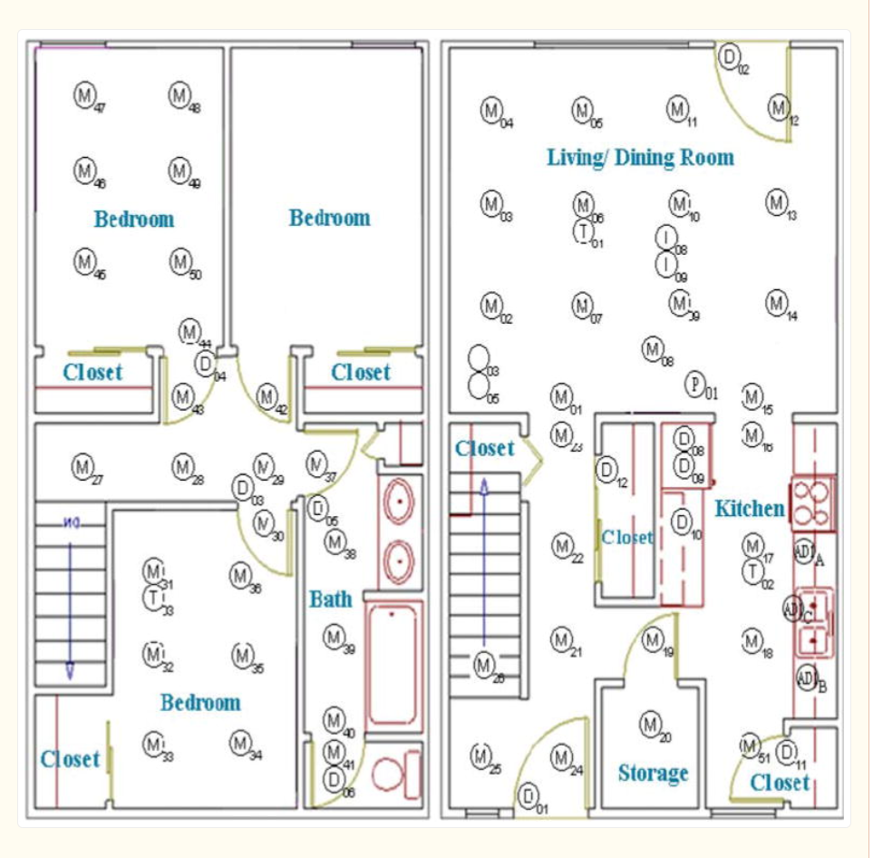

The Solution: Hidden Markov Models (HMM)
The core technology used to understand the sensor data is a statistical tool called a Hidden Markov Model (HMM).
However, you can see smoke coming from the chimney and hear plates clattering (the evidence is Observable).
- Observable State: The sensors firing (Motion in kitchen + Stove On).
- Hidden State: The actual activity (Cooking Dinner).
The computer uses the Viterbi Algorithm to look at the sequence of sensor "clues" and calculate the most statistically probable story of what is happening inside.
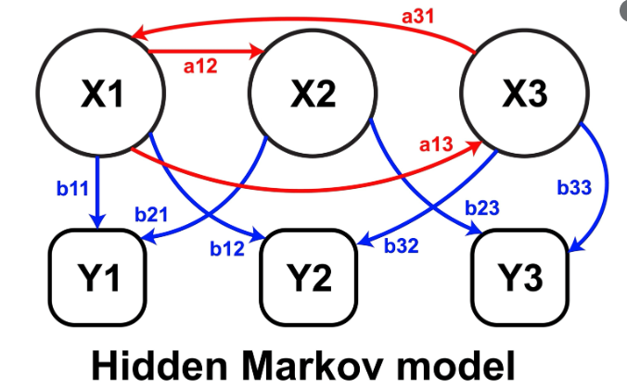

Key Findings and Results:
Experiment A: The "One Big Brain" Approach
They fed all the data from both residents into a single model without telling the computer who was who.
- Result: 60.60% Accuracy.
- Why: The model struggled because the data was too chaotic. It couldn't easily tell the difference between one person moving quickly and two people moving slowly.
Experiment B: The "Separate Identities" Approach
They created two separate models—one for Person A and one for Person B—assuming the system could identify which person triggered a specific sensor.
- Result: 73.15% Accuracy.
- Why: By separating the residents, the computer could much more easily recognize patterns.
Interesting Insights:
- Long vs. Short Activities: The system was very good at spotting long activities like "Reading a Magazine" (94% accuracy) because there was lots of data. It was bad at spotting short activities like "Setting the Table" (21% accuracy) because the event happened too fast to generate a clear pattern.

Conclusion:
- The paper concludes that probabilistic models (like HMMs) are effective tools for monitoring health and safety in homes with more than one person.
- However, for this to work in the real world (outside of a test lab), the system needs to be better at distinguishing who triggered a sensor. If we can accurately track multiple residents, we can provide automated health monitoring that allows elderly individuals to live safely and independently with their spouses or family members.

Paper 3:
Real-Time & Streaming Data (Sequential)
Title: Activity Recognition on Streaming Sensor Data
Author/Year: Krishnan & Cook, 2014
Link: https://pmc.ncbi.nlm.nih.gov/articles/PMC3979570/
The primary objective of this research is to advance Smart Home technology from analyzing past data to understanding human behavior in real-time.
Most existing Activity Recognition (AR) systems cheat slightly: they analyze data that has already been cut into neat little "episodes" (e.g., a file labeled "Cooking"). However, real life is a continuous stream of events without clear start or stop buttons. This paper proposes a Sliding Window approach to identify activities (like eating, sleeping, or working) instantly as sensors are triggered, making the system viable for real-world alerts and assistance.
The Challenge: The "Streaming" Problem:
- The Old Way (Offline/Segmented): Researchers usually ask a user to "go cook dinner," record it, and then teach a computer what "cooking" looks like. This is easy because the computer knows exactly when the activity started and stopped.
- The Real World (Online/Streaming): In a real home, a person might walk from the bedroom to the kitchen, answer the phone, cook a bit, and then go to the bathroom. The sensors just see a long list of "ON/OFF" signals.
- The Goal: The computer needs to look at the latest sensor click and immediately decide: "What is the user doing right now?" without waiting for the activity to finish.

The Solution: The Sliding Window Approach:
- To solve this, the researchers use a technique called a Sliding Window. Imagine looking at the sensor data through a small moving frame that only shows the last 20 sensor events.
- However, a basic window isn't smart enough. The paper introduces three major enhancements to make this window intelligent:

A. Time Weighting (SWTW)
In a standard window, a sensor that triggered 30 minutes ago counts the same as a sensor that triggered 1 second ago. This is often wrong.
  - The Fix: The researchers applied Time Decay.
  - How it works: Recent events are given a "heavy" weight, while older events in the window fade away mathematically using an exponential function. This ensures the computer focuses on the "now."
B. Sensor Dependency / Mutual Information (SWMI)
Some sensors naturally go together. If the "Stove" sensor is ON, the "Kitchen Cabinet" sensor is likely relevant. The "Bedroom Light" is likely irrelevant noise.
- The Fix: The system calculates Mutual Information.
- How it works: It looks at how often two sensors trigger together. If Sensor A and Sensor B are "friends" (frequently paired), the system boosts their importance when they appear in the same window.
C. Past Context (PWPA)
Human behavior follows patterns. You rarely go from "Sleeping" directly to "Leaving Home" without "Dressing" or "Eating" first.
- The Fix: The system looks at history.
- How it works: To decide what is happening now, the system considers what activity it detected in the previous window. If the previous activity was "Leave Home," the current activity is very likely "Enter Home" and very unlikely to be "Cooking."
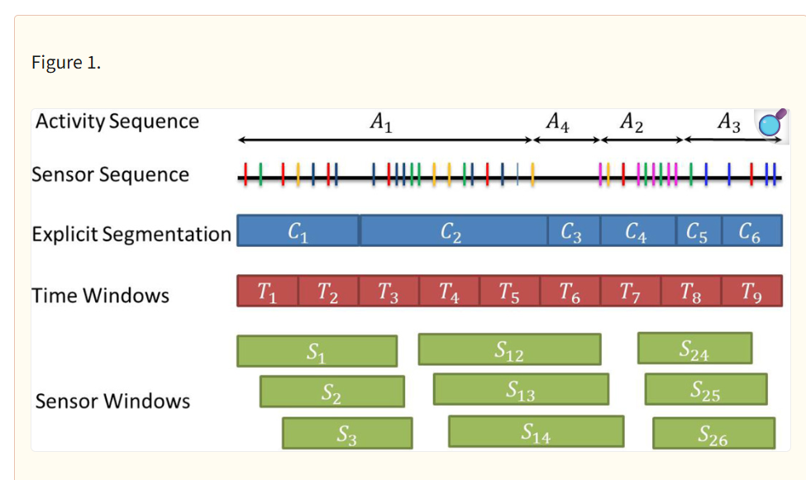
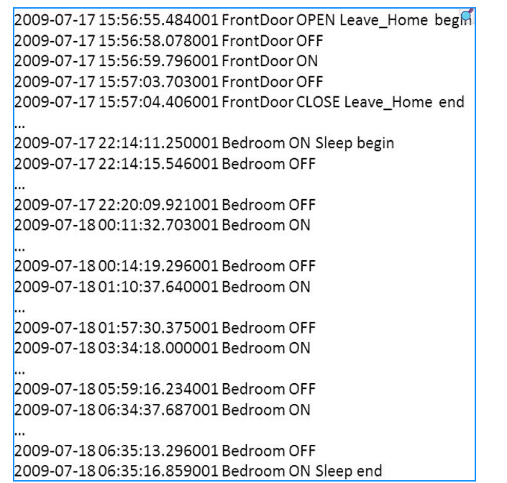

Experimental Setup:
To test these theories, the researchers did not use a lab. They used real homes.
- The Testbeds: Three smart apartments (labeled B1, B2, B3).
- The Residents: Elderly individuals living their normal lives.
- The Duration: Data collected over 6 months.
- The Sensors: Simple binary sensors (Motion Detectors and Door/Cabinet sensors).

Key Findings and Results:
- Window Size Matters: They found that a window size of roughly 20 sensor events was the "sweet spot." Smaller windows missed context; larger windows got confused by old data.
- Best Combination: The most accurate system combined Mutual Information (SWMI) with Past Context (PWPA).
  - Why: This combination understood which sensors belonged together physically and understood the logical flow of human daily routine.
- Specific Activity Improvements:
  - Activities like "Enter Home" saw massive accuracy improvements (up to 41% increase) because the system knew the user had previously "Left Home."
- The "Other" Class Difficulty:
  - About 50% of the data in real life is "Other" (random movements not part of a specific labeled activity). The system still struggled to distinguish specific activities from this random noise, identifying this as a key area for future work.

Conclusion:
The paper demonstrates that online activity recognition is possible using discrete motion sensors. By moving away from simple counting and instead weighting sensors based on time, location relationships, and historical context, a smart home can accurately track a resident's routine in real-time. This is a critical step toward creating automated caretakers for the elderly.

